AT SALONE DEL MOBILE. MILANO 2018 iDOGI® PRESENTS
“VERSAILLES”
PRECIOUS BALUSTRADE WITH ARTISTIC COLUMNS IN PURE CRYSTAL
WORLD PREMIERE
FOR THE MOST LUXURY INTERIORS

Celebrating the 50th Anniversary from the foundation (1968-2018), at Salone del Mobile.Milano 2018,
iDOGI® is excited to announce the world premiere of a new concept for the most luxury interiors:

“VERSAILLES”.
SPECTACULAR BALUSTRADE WITH ARTISTIC LUMINOUS COLUMNS IN PURE CRYSTAL.

Created to highlight the greatness of lavish grand stairs in luxurious palaces and mansions all around the world, the exclusive design of this new concept amazes the viewer beyond the records.
Every single column is entirely handmade and it proves the obsessive care for detailing, expressing an uncompromising excellence.
The facets of crystals create endless reflections and light up the space from the columns' inside to the outside, creating spectacular games of refraction all around the surrounding context.
Art and light blend into this unique work and the atmosphere becomes enchanting.
Extraordinary luxury for extraordinary people.

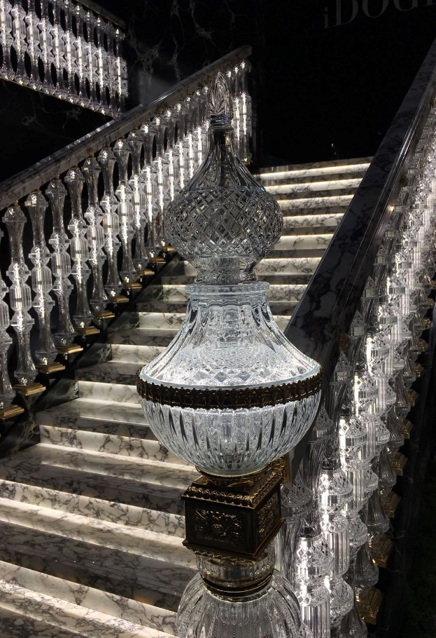 | 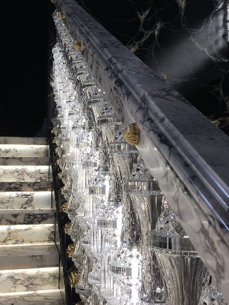
 | 