iDOGI pays tribute to Venice’s creativity, arts and crafts-making with
LE MUSE, a collection of kaleidoscopic glass creatures

Salone del Mobile.Milano 2022, 7-12 Giugno – Pav. 4-XLUX, F09-F11
Press kit: www.tinyurl.com/idogi-milano-2022

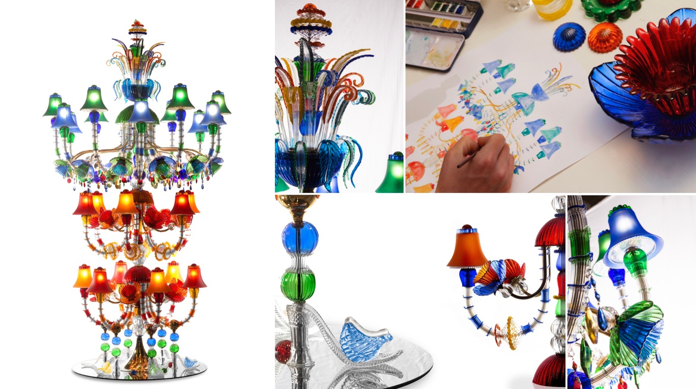

In Greek mythology, the Muses are the arts, science, and literature goddesses. From here, Venetian company iDOGI took inspiration to ‘forge’ LE MUSE, a series of unique sculptures, each dedicated to the arts, science and crafts related to the city of Venice. Like surreal creatures with their own distinctive spirit and attitude, the new muses also invite us to reflect on the Italian city’s heritage as well as on its present challenges and opportunities - An approach matching perfectly with iDOGI’s values and vision for the future.

Founded in 1968, the Italian company creates Murano glass masterpieces and exclusive lighting projects harnessing and bringing forward the expertise of Venetian glass masters. “With LE MUSE, we created an innovative lighting monument to joy and exuberance.” Says Domenico Caminiti, President of iDOGI. “We like to imagine this vibrant sculpture like a free-standing chandelier celebrating and, at the same time, breaking the rules of Venice glassmaking.”

Indeed, the first muse rises from the ground and captures the eye with a joyful explosion of colour. The 2.80 metre tall sculpture combines both classical and contemporary elements, over 1.500, each highly crafted to the finest detail. Once lit, shades of different hues and a play of transparencies intertwine, creating an almost dancing effect. Danza is indeed the art the ‘creature’ pays tribute to. The monumental glass whirlwind is defined by six jewel sandals, all handcrafted in Murano glass in spectacular colours and inspired by the six continents reached by Venetian arts and crafts.

Danza will preside, muse and welcome the visitors of the Museo della Calzatura di Villa Foscarini Rossi. The influential museum features over 1.500 women’s luxury shoes manufactured in Italy in the past 70 years. Acquired by the LVMH group, it is located in a 17th-century villa in Stra, in the province of Venice. “On the occasion of the United Nations International Year of Glass that aims to promote the importance of a material bringing forward innovation and culture, it is with great honour and pleasure that we welcome ‘Danza’ in the entrance hall of the Museum. A true homage to Venice and a magic presence born from the genius loci of our territory.” Comments the museum’s director Cristina Rossi.

Danza is the first ‘creature’ of Le Muse’ collection of unique pieces. Other muses are set to ‘walk’ and shine a light on Venice’s greatest treasure: its people and their skills to craft beauty from water and fire.

•••

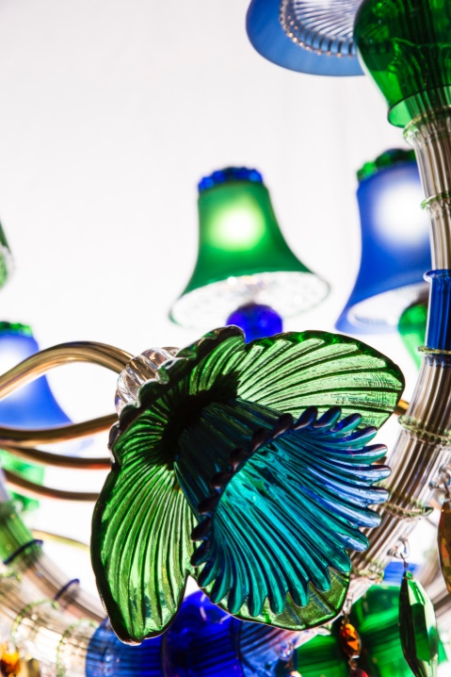
iDOGI is a Venice-based company renown for creating bespoke majestic chandeliers and high-end Murano glass sculptures and furniture for some of the world’s most prestigious palaces and homes. Its luminous collections comprise iconic lighting designs, tables, balustrades and crystal fountains. The unique pieces are custom-designed by a team of experienced designers and then handcrafted by highly skilled glass masters in order to meet the expectations of demanding clients. https://www.idogi.com/

Instagram: @idogi_italy #iDOGI

Press Office: Agenzia OTTO iDOGI
Enrico Zilli, Alessandra Beretta Via dell’Avena 15 – 30175 Venice, VE, Italy
+ 39 3471682396, +39 3756517300 +39 041 926251
e.zilli@ottoidee.it – a.beretta@ottoidee.it idogio@idogi.com

