iDOGI has created a magic box at Salone del Mobile in Milan
Crystal and Venetian art glass are dressed with light to create architecture and furnishings that combine both the traditional and the contemporary

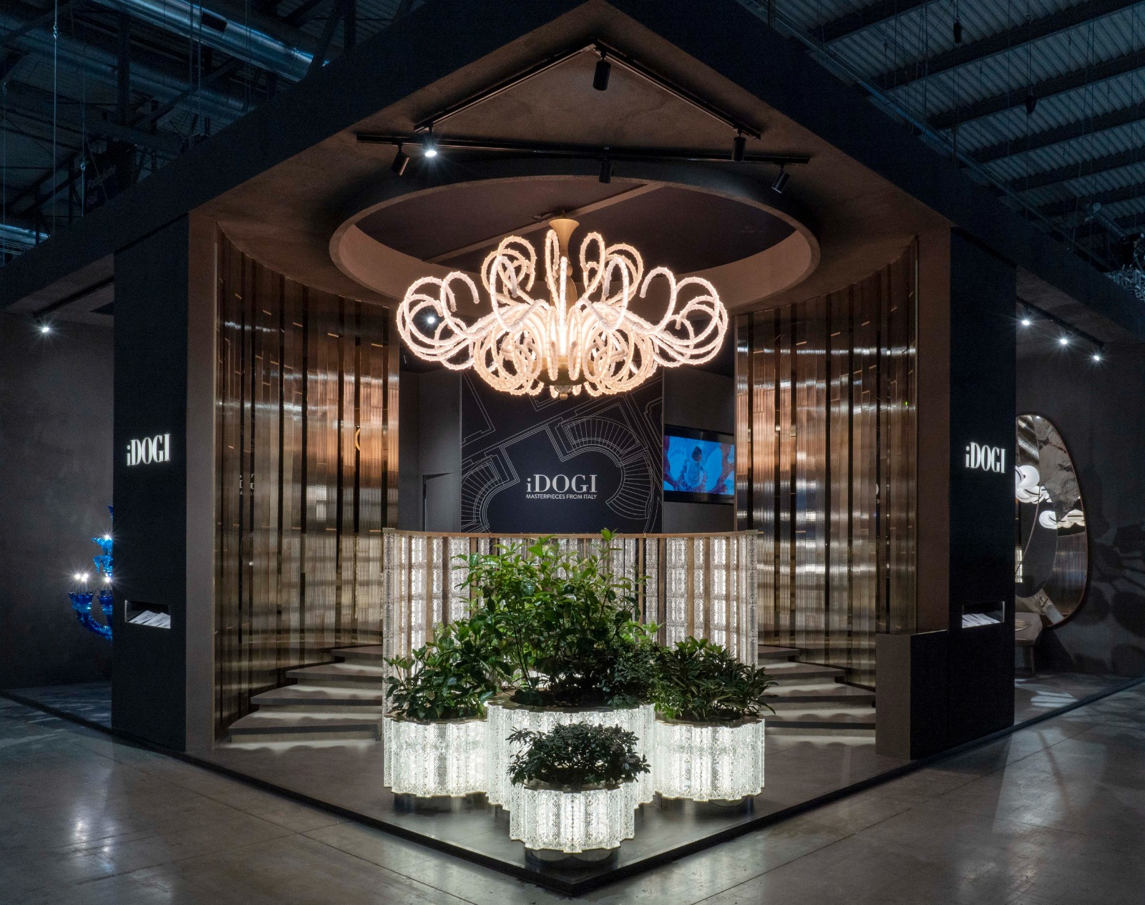

The spectacular stand with a glass and crystal staircase. A majestic total-blue chandelier, endless light structures and 1920s inspiration with a contemporary twist. The new language of iDOGI is endless and limitless, both in terms of space - with exclusively made-to-measure designs and infinitely expandable collections - and of time with furnishings that blend styles to transcend fashions.

iDOGI's magic box at the Salone del Mobile is a treasure trove of light in which the centuries-old tradition of Venetian art glass meets 1920s inspiration, contemporary monochromes, architectural design and modernist nuances. The company is world-renowned for the creation of 'bespoke' majestic Venetian art glass chandeliers, sculptures and furnishings.

In Milan, iDOGI highlights its experimental and design-driven approach. “Each of our creations is always and exclusively made-to-measure, developed with teamwork between our style office, customers and their team. To better illustrate how we work, we have set up a real atelier where our designers show the design work of some of our most recent creations,” comments Domenico Caminiti, President of iDOGI.

iDOGI @ Salone del Mobile DOWNLOAD THE PRESS KIT:
18-23 April 2023 https://tinyurl.com/idogi-milano-2023
XLUX - Hall 3, Stand D21 Agenzia OTTO: Enrico Zilli +39 3471682396 – e.zilli@ottoidee.it
https://www.idogi.com/

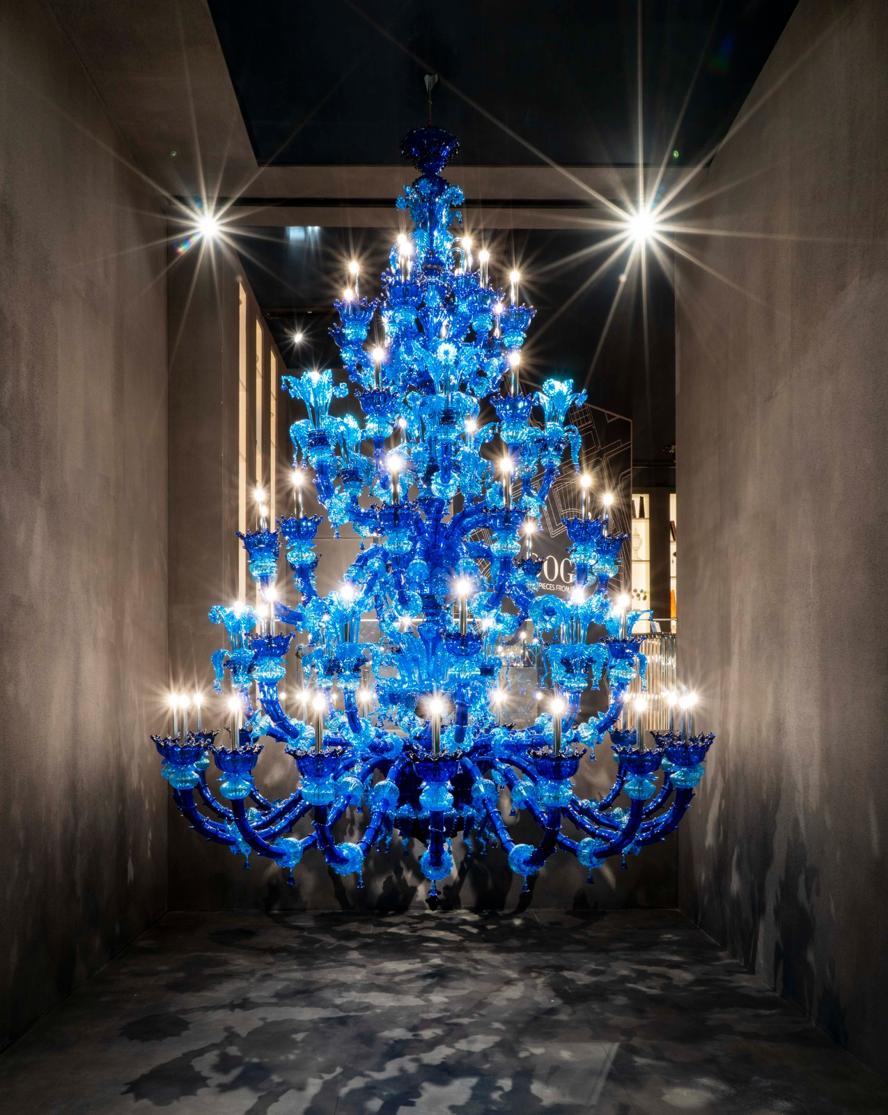

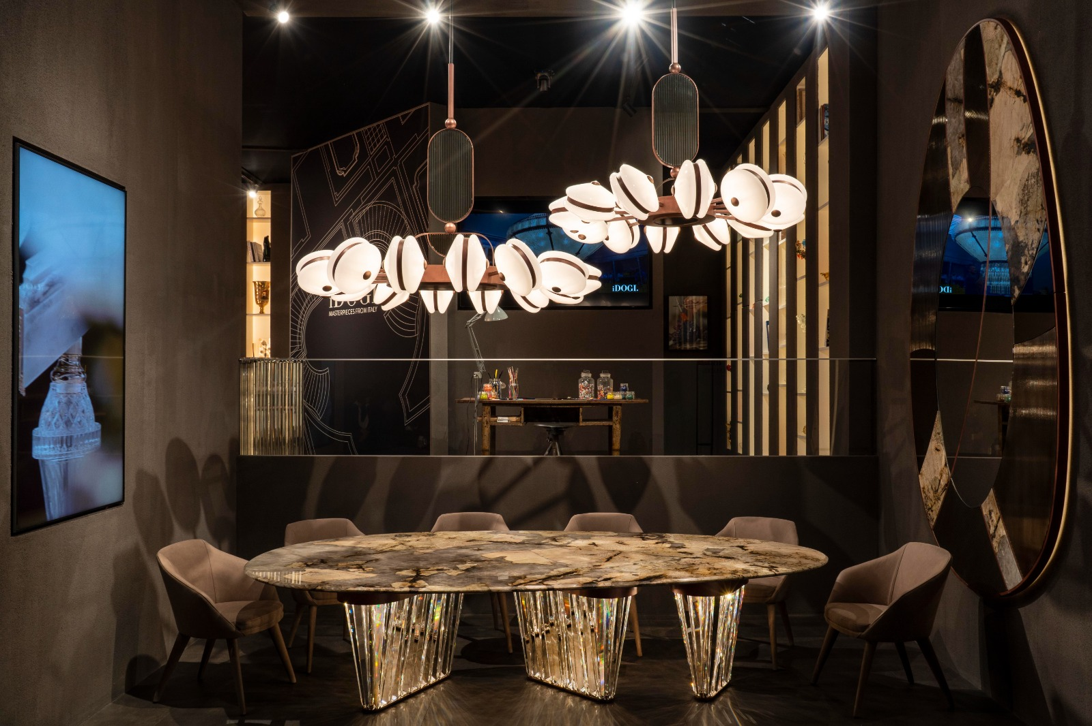

THE NEW COLLECTIONS

Endless - Architectures of Light

The characteristic feature of the light staircase is Endless, a precious crystal light column embellished with delicate bevelled decorations and the most advanced lighting solutions available anywhere. The result is a luxurious module with a dimmable and totally invisible light source that can be combined with other units to create luminous partitions and infinite compositions. The new modular lighting system gives an unlimited level of customisation - Endless, precisely.

Crystal Garden

At the base of the staircase, reaching out towards the visitor and overflowing with life, are the majestic Crystal Garden planters. Perfect for fine interiors, the large planters can be customised in different sizes, and also add magic to terraces and covered gardens. Regular geometries and bold angles, golden reflections and composite patterns give Crystal Garden an elusive modernist edge.

Le Grand Bleu

Like the French movie of the same name, Le Grand Bleu is the story of a challenge. That of combining the great tradition of Rezzonico-style Venetian chandeliers with a statement total-blue look for a fresher, more contemporary approach. "The prestigious residences and palaces of our clients often house several generations of the same family, each with their own taste. This is why we chose to create a monochrome Rezzonico in light-blue tones, with a more contemporary character." Domenico Caminiti comments.
Comprising over 3,000 pieces, each finely crafted by hand, Le Grand Bleu is 4 metres high with a diameter of 3 metres. Inside, a mighty metal structure supports the work, remaining completely invisible to give space to carefully embedded light sources that create organic and natural reflections.

Zelda & Scott

In the most intense years of their love, Zelda and Francis Scott Fitzgerald best represent the carefree, irresponsible, naive and thirsty spirit of 1920s New York. 'All I want is to be very young always and very irresponsible,' said Zelda Sayre Fitzgerald, writer, artist and socialite. "I don't want to repeat my innocence. I want the pleasure of losing it again." Said her husband and life partner, Francis Scott Fitzgerald, writer of such masterpieces as The Great Gatsby, This Side of Paradise and The Beautiful and Damned. It is this attitude, along with the writings, that have inspired the new Zelda and Scott furniture collections, which reinterpret the Art Deco verve, and the sparkling, eclectic spirit of the Roaring Twenties in a contemporary vein.

The Scott chandeliers consist of satin white glass capsules that form spheres arranged around a central body. Like moons or planets, the spheres appear to rotate around their own orbit, each at a different angle, creating a kind of luminous dance that floats over the room. The large Zelda table consists of three powerful backlit crystal legs supporting an ovoid marble top 300 cm long and 160 cm wide. A slab of Patagonia marble was chosen for the exhibition. The table is accompanied by an unexpected oblong mirror. The reflective surface is a patchwork of different finishes, and materials that creates an eclectic and dynamic work of art.

Capriccio

In classical music, a Capriccio is a typical 17th century composition with a cheerful, light-hearted character, yet often complex and for virtuosos, like Paganini's 24 capriccios, or like the typical Venetian capriccios and rondos. Fugues and cascades of notes alternate freely, rather like the 'tentacles' of the namesake chandelier, which seems almost to be playing capriccios too.

***

iDOGI is a company founded in 1968 and based in Venice, renowned for creating 'bespoke' majestic Venetian art glass chandeliers, sculptures and furnishings for some of the world's most exclusive palaces and residences. Its lighting collections include extraordinary design pieces, tables, balustrades, and crystal fountains. All creations are custom-designed by a team of expert designers in the company's Style Department, and handmade by the best glass masters to meet the expectations of the most prestigious clients. https://www.idogi.com/

iDOGI @ Salone del Mobile iDOGI Spazio Milano
18-23 April 2023 Via dell’Avena 15, 30175 Venezia
XLUX - Hall 3, Stand D21 +39 041 926251– idogi@idogi.com

iDOGI Spazio Milano
Foro Buonaparte 55, 20121 Milano – MM Cadorna.
+39 02 3928 4525 – milano@idogi.com
Appointment recommended.

DOWNLOAD THE PRESS KIT: https://tinyurl.com/idogi-milano-2023

Instagram: @idogi_italy #iDOGI

